u|Lg ;f];fO6L klAns :s'n

/=g=kf=–&, ;f}/fxf, lrtjg

k|yd q}dfl;s kl/Iff

;doM @ 306f

**laifoM** g]kfnL **k"0ff{ª\sM** %)

**sIffM** o'= s]= hL= **pQL0ff{+sM** !*

**gfd……============================================= /f]n g+================================ ;]S;g======================**

**k|fKtfË**

ko{j]Ifs

k/LIfs

**k|Zg g+= ! b'O{ cIf/n] ag]sf zAbx¿ n]Vg'xf];\ . -%_**

**k|Zg g+= @ tLg cIf/n] ag]sf zAbx¿ n]Vg'xf];\ . -%_**

**k|Zg g+= # …‘s’ b]lv ‘sM’ ;Dd qmd ldnfP/ hf]8\g'xf];\ . -%_**

**s ls s' s] sf] s+**

**sf sL s" s} sf} sM**

**k|Zg g+= $ j0f{ hf]8]/ n]Vg'xf];\ . -%_**

**k|Zg g+= % bL3{ Osf/ -L_ nfu]sf zAbdf uf]nf] 3]/f nufpg'xf];\\ . -%_**

**/fgL dnd znud**

**6]an r/L h'gf/**

**Dffdf d;L emf]nf**

**hLjg df]6f] o1**

**kj{t j+z aL;**

**k|Zg g+= ^ :j/ j0f{ / dfqf aLr hf]8f ldnfpg'xf];\ -%_**

cf }

O{ ]

P f

c+ f}

cf} +

P] L

**k|Zg g+= & zAb agfpg'xf];\ . -^_**

-------------------------------- ------------------------------

-------------------------------- ------------------------------

-------------------------------- ------------------------------

**k|Zg g+= * lrq x]/]/ gfd n]Vg'xf];\ . -^_**

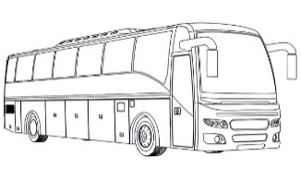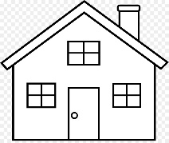

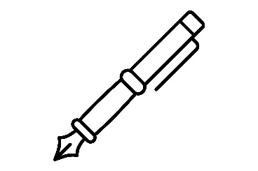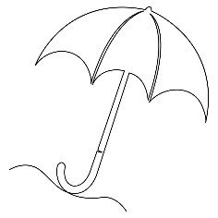

**k|Zg g+= ( zJbx? hf]8]/ jfSo agfpg'xf];\ . -^_**

lstfa ahfpm .

lx;fa k9 .

lutf/ u/ .

;dfKt

**The End**

Green Society Public School

Ratnanagar-7, Sauraha, Chitwan

First Term 2082

Time: 2 hrs.

**Subject: Maths Full Marks: 50**

**Class: UKG Pass Marks: 18**

**Name:________________________Roll No:_______ Sec:_______**

**____________ _________**

**OBT. MARKS**

**INVIGILATOR EXAMINER**

1. **Compare the picture and write ‘more’ ‘equal’ and less. (3)**

|  |  |  |
| --- | --- | --- |
|  |  |  |

**b.**

|  |  |  |
| --- | --- | --- |
|  |  |  |

**c.**

|  |  |  |
| --- | --- | --- |
|  |  |  |

1. **Write down firm 31-40. (5)**

1. **Write down 5/5 odd and even numbers. (5)**

|  |  |
| --- | --- |
| **Odd** | **Even** |
|  |  |
|  |  |
|  |  |
|  |  |
|  |  |

1. **Write down firm (@!–#)) (5)**

1. **Put sign ‘<’, ‘>’ and ‘=’. (5)**

6◻8

13◻27

27◻27

20◻16

19◻19

1. **Write the numbers name. (5)**

**21=……………….**

**16=………….…..**

**30=……………….**

**7=…………………**

**25=……………….**

**7) cª\snfO{ cIf/df n]Vg'xf];\ . -5_**

**$ Ö !) Ö**

**& Ö !& Ö**

**!! Ö**

1. **Write the name of shape. (5)**
2. Re-arrange the numbers in descending order. (6)

18 14

15 =

11 12

17

5 9

2

1. **What comes after, before and between. (6)**

|  |  |  |
| --- | --- | --- |
| **Before** | **Between** | **after** |
| **………….7**  **………...12** | **7………….9**  **12……..…14** | **27………….**  **41…….……** |

**The End**

Green Society Public School

Ratnanagar-7, Sauraha, Chitwan

First Term 2082

Time: 2 hrs.

**Subject: English Full Marks: 50**

**Class: UKG Pass Marks: 18**

**Name:____________________Roll No:__________Sec:_________**

**____________ _________**

**OBT. MARKS**

**INVIGILATOR EXAMINER**

1. **Circle the consonant letters only.. (3)**

b I k

a f c

o g h

1. **Write down vowel letters. (5)**

**.**

1. **Make 2/2 words. (5)**

B

C

F

O

N

1. **Make 'at' words. (5)**

…………………………… ……………………………….

…………………………... ……………………………….

…………………………...

1. **Put ‘a’ or ‘an’ before word. (5)**

**a. Ink**

**c. pan**

**e. rose**

**b. eye**

**d. ant**

1. **Circle the non -rhyming word. (5)**

Pit Kid sit fit

Box mom pox fox

Pud bud cud bus

ted led fed yes

peg beg hem keg

1. Make sentences using ‘This’ and ‘That’. (5)
2. ……………… is an apple.
3. ……………..is a Banana. 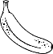
4.  ………….. is a pen.
5. …………… is a book. 
6. ……….is a Butterfly.
7. 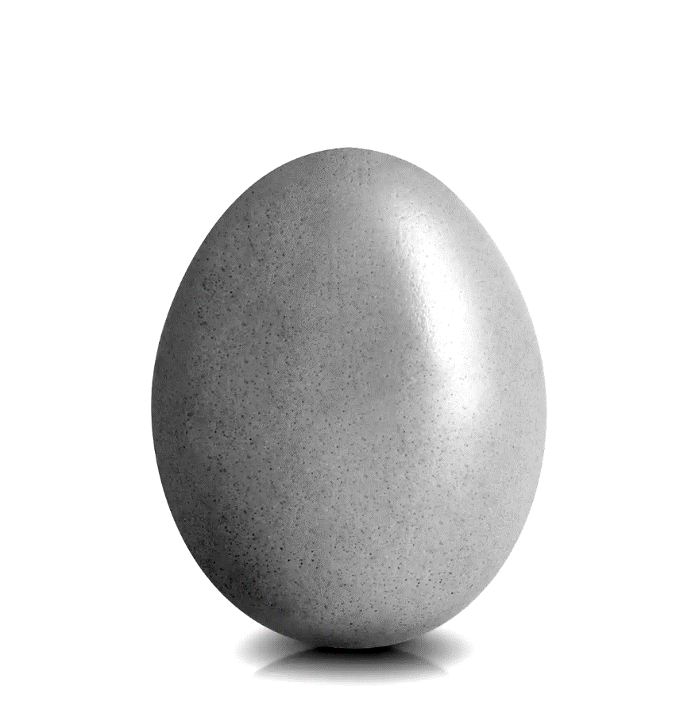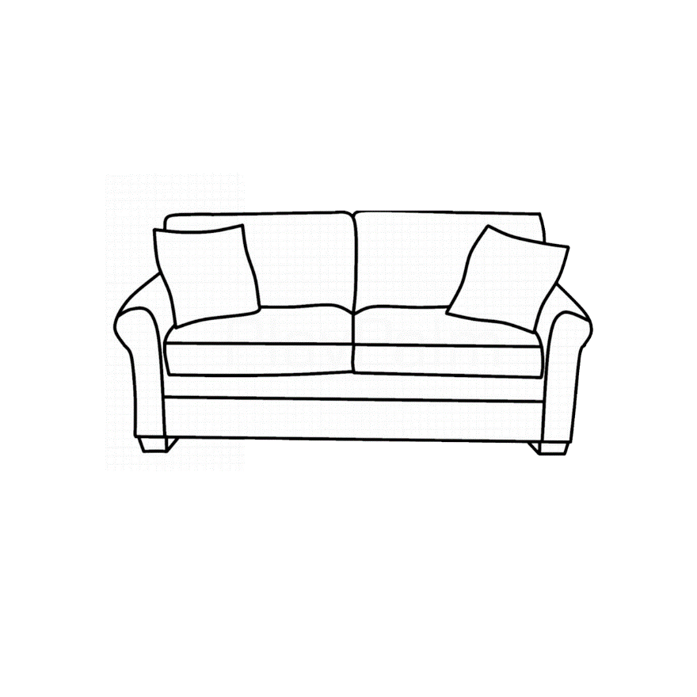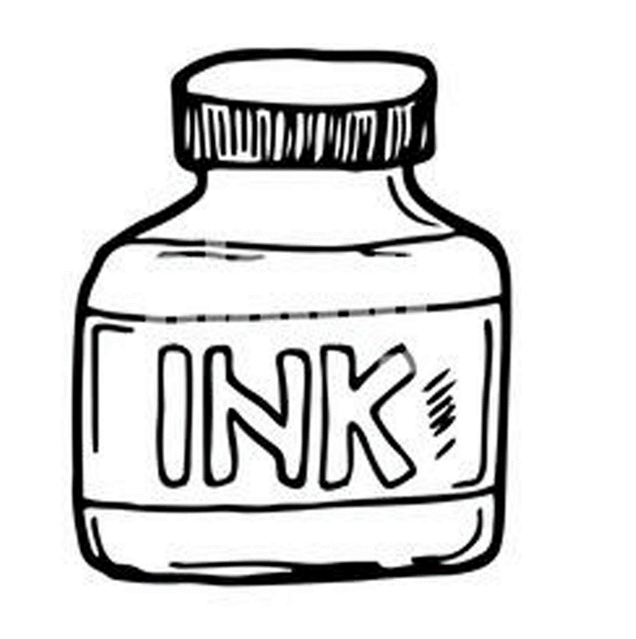**Write the name of given picture. (5)**

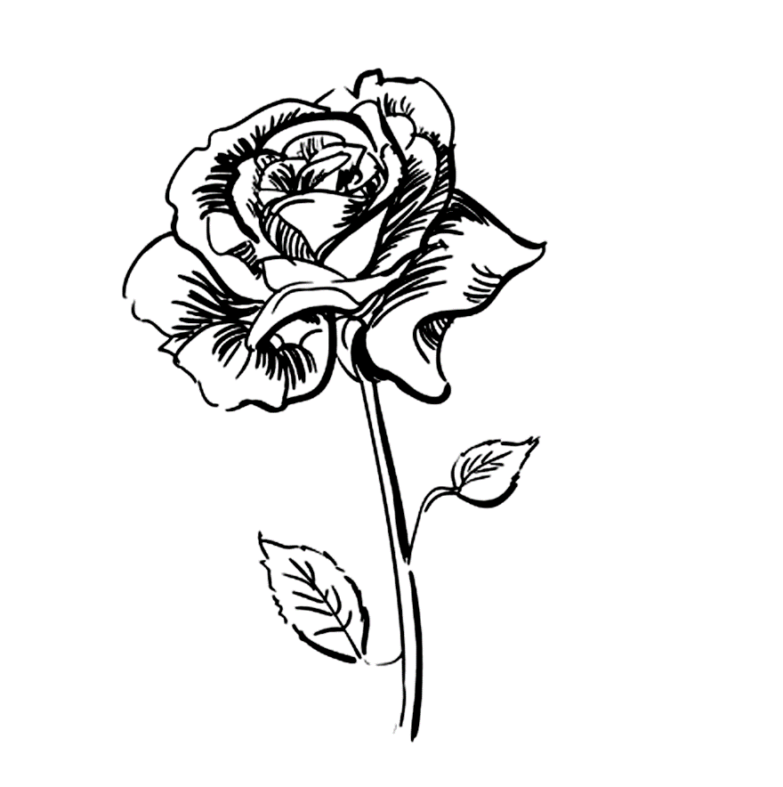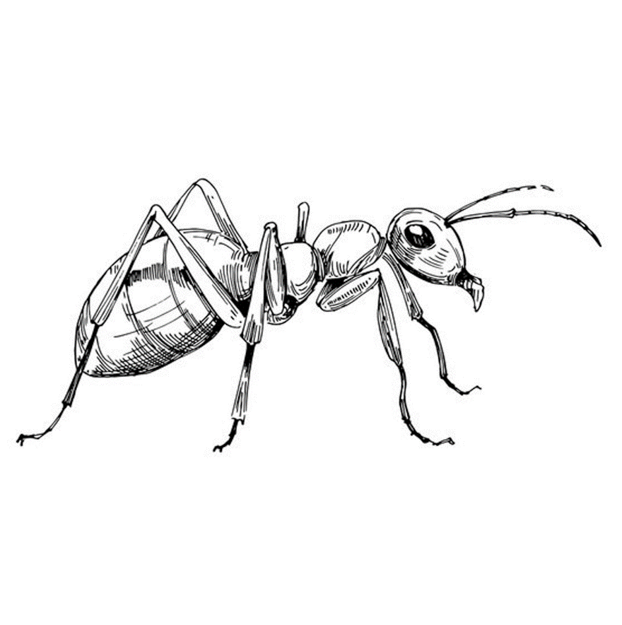



1. **Fill in the missing letters. (6)**
2. **e…....e b. l…....g c. h…....a…….**

**d. n…....s….... e. e…....r f. l..…..p……..**

1. **Make sentences with the given table. (6)**

Green Society Public School

Ratnanagar-7, Sauraha, Chitwan

First Term 2082

Time: 2 hrs

**Subject: Social Science Full Marks: 50**

**Class: UKG Pass Marks: 18**

**Name:____________________Roll No:__________Sec:_________**

**____________ _________**

**OBT. MARKS**

**INVIGILATOR EXAMINER**

1. Write any 5 Polite words? (5)

…………………. …………………. ……………………….

…………………….. ……………………

1. Match the same family members. (5)

|  |  |  |
| --- | --- | --- |
| Handsome Grandfather Coloring Pages |  | Sister |
| Grandmother Line Drawing SVG Cut file by Creative Fabrica Crafts · Creative  Fabrica |  | Mother |
| Man Smiling - Father Or Dad | Royalty-Free Vector Stock | FreeImages |  | Grandmother |
|  |  | Grandfather |
| Sister |  | Father |

1. Write name of road transportation? (5)

…………………. …………………… …………………….

…………………….. …………………..

1. 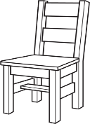Write name of the given picture. (5)

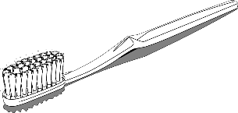

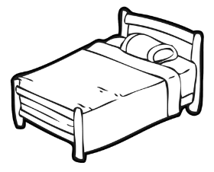

1. Write the name of Community helpers. (5)

………………….. ………………….. ………………….

…………………. …………………..

1. Write the name of body parts. (5)

………………….. ………………….. ………………….

…………………. …………………..

1. Write the name of living things. (5)

………………….. ………………….. ………………….

…………………. …………………..

1. Circle the word that matches with the picture of sense organs. (5)

|  |  |  |  |  |
| --- | --- | --- | --- | --- |
| Eye Black And White Vector Art, Icons, and Graphics for Free Download | Lie | Eye | Pie | Ear |
|  | Sung | Lung | Tongue | Tung |
|  | Fear | Near | Dear | Ear |
|  | Rose | Rose | Pose | Jose |
|  | Skin | Ear | Eye | Nose |

1. Write the name of the domestic animals. (5)

……………………. ……………………. …………………….

……………………. …………………….

1. Mach the following. (5)

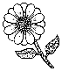

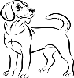Fruit

Vegetable

Insect

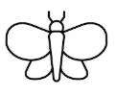Bird

Animals

Flowers

Green Society Public School

Ratnanagar-7, Sauraha, Chitwan

First Term 2082

Time: 2 hrs

**Subject: Rhymes & Conversation Full Marks: 50**

**Class: UKG Pass Marks: 18**

**Name:____________________Roll No:__________Sec:_________**

**____________ _________**

**OBT. MARKS**

**INVIGILATOR EXAMINER**

Answer the following questions:

1. What is your name?
2. In which class do you read?
3. What is your father's name?
4. What is your mother's name?
5. What is your school name?
6. What is your class teacher's name?
7. what is your country name?
8. What is your school principal's name?
9. What is your School vice principal's name?

!)= tkfO{ slt jif{sf] x'g'eof] <

!!= g]kfnsf] /fli6«o hgfa/sf] gfd s]xf] <

!@= g]kfnsf] /fli6«o km'nsf] gfd s] xf] <

!#= g]kfnsf] /fli6«o /ªsf] gfd s] xf] <

!$= g]kfnsf] /fli6«o xltof/sf] gfd s] xf] <

15. Rhumes

16. Dance

!&= tn lbPsf lrqx¿sf] gfd eGg;xf];\ .

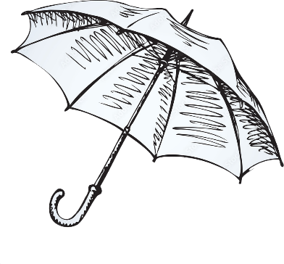

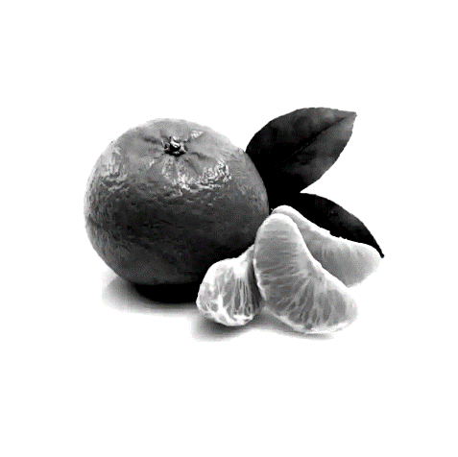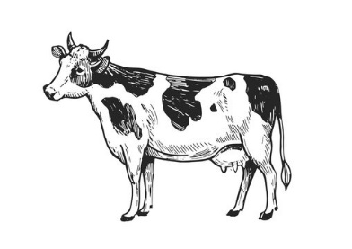

Green Society Public School

Ratnanagar-7, Sauraha, Chitwan

First Term 2082

Time: 2 hrs

**Subject: Project and activity Full Marks: 50**

**Class: UKG Pass Marks: 18**

**Name:____________________Roll No:__________Sec:_________**

**____________ _________**

**OBT. MARKS**

**INVIGILATOR EXAMINER**

1. 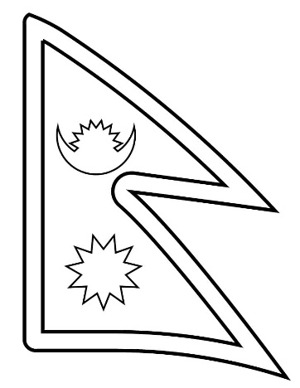Colour it. 10
2. 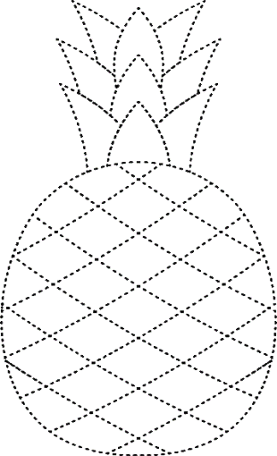Join the dotted line and colour it. 10
3. Draw a picture of butterfly and colour it. 10
4. 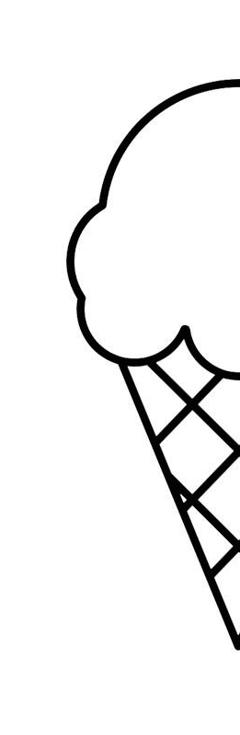Complete the half picture and colour it. 20 

u|Lg ;f];fO6L klAns :s'n

/=g=kf=–&, ;f}/fxf, lrtjg

k|yd q}dfl;s kl/Iff

;doM @ 306f

**laifoM** g]kfnL **k"0ff{ª\sM** %)

**sIffM** on= s]= hL= **pQL0ff{+sM** !*

**gfd……============================================= /f]n g+================================ ;]S;g======================**

**k|fKtfË**

ko{j]Ifs

k/LIfs

**k|Zg g+= ! jfSo k9\g'xf];\ / n]Vg'xf];\ . -#_**

**hn e/**

**a; r9**

**snd ug**

**k|Zg g+= @ p:t} cIf/df uf]nf] 3]/ nufpg'xf];\ . -%_**

**cÖ cf c**

**cfÖ 5 cf**

**pÖ O p**

**OÖ 8 O**

**cf]Ö cf] c**

**k|Zg g+= # zJb agfpg'xf];\ . -%_**

**k|Zg g+= $ lrq x]l/ klxnf] cIf/ n]Vg'xf];\ . -%_**

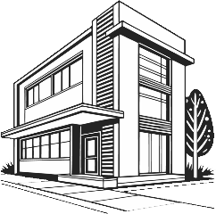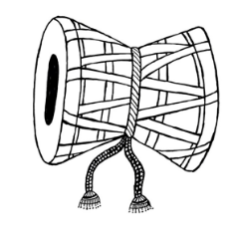



**k|Zg g+= % s|d ldnfP/ hf]8\g'xf];\ . -%_**

**r 5 ` 6**

**h em 7 8**

**9 0f**

**k|Zg g+= ^ b'O cIf/n] ag]sf zAbx? n]Vg'xf];\ . -%_**

**k|Zg g+= & k5fl8 cfpg] cIf/ n]Vg'xf];\ . -^_**

**u 8 r**

**h 6 k**

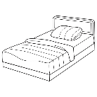**k|Zg g+= * zAb / lrq hf]8f ldnfpg'xf];\ . -^_**

**sk**

**hu**

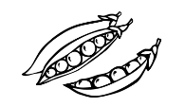**an**

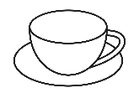**knª**

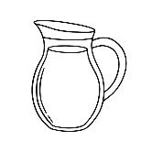**sdn**

**d6/**

**k|Zg g+= ( vfln 7fpF eg'{xf];\ . -!)_**

**t b g k a d n z ; If 1 .**